**Top 100 Spotify streamed songs.**

**EXPLANATION OF DATA SET:**

* ***The dataset is about 100 Most streamed songs on Spotify of all time.***
* ***It contains 100 unique rows in which each row contains values of one song.***
* ***There are 14 columns in the dataset where each column contains data of an important aspect of a song.***
* ***Columns has basic information such as Name of the song, Artist, Genre, Year of release, Length and Popularity of the song***
* ***It also contains some more detailed information of a song such as.***

1. ***Beats per minute.***
2. ***Energy (****where 0 is lowest and 100 is highest).*
3. ***Danceability (****where 0 means lowest and 100 is highest).*
4. ***Loudness in decibels*** *(where 0 decibel is loudest and value such as –15 is quieter level).*
5. ***Liveness: It means number of people at the time of recording*** *(where 0 is lowest and 100 is highest).*
6. ***Valence: It is how positive a song is*** *(where 100 is most positive and 0 is least positive i.e., negative).*
7. ***Acousticness: It means number of non-electric instruments used while recording the song*** *(where 0 means all the used instruments were electric and 100 means none of the instruments were electric).*
8. ***Speechiness: It is Ratio of vocal and Music in a song*** *(where 0 is least vocal used and 100 is most vocal used).*

**DATA SET:**

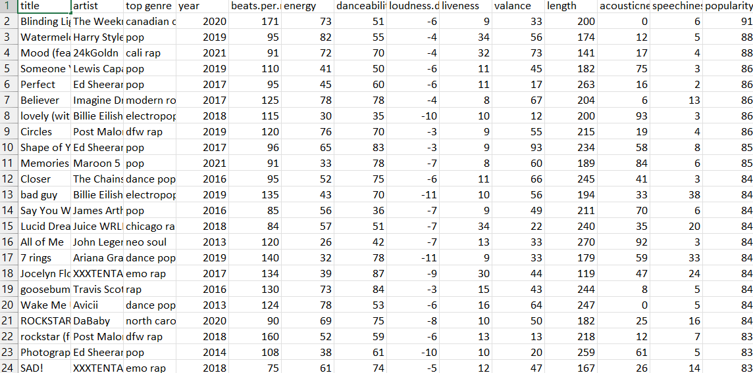

**Questions:**

***The questions that are asked on the data set are based on two Aspects.***

* ***From the Perspective of a Music Composer / Singer wishing to compose a popular song.***
* ***From the Perspective of an Analytic trying to find some similarities in the songs and giving answers to some questions*.**

***Question based on dataset:***

1. ***What is the good decibel range for a song?***
2. ***What is the relation between danceability and beats per minute?***
3. ***Relation between liveness and genre, are some specific genre that includes more people at the time of recording?***
4. ***Does a specific genre have more valence (Positiveness conveyed by the song) if yes which genre? does valence increase?***
5. ***Are Energy and Loudness of a song related? does more energy requires more loudness and vice versa?***
6. ***Does a specific genre have a limit to use electrical instrument, which genre has highest acousticness and which has lowest?***
7. ***Through the year which genre is most popular?***
8. ***Does the genre electro-pop that has electro in its name have the greatest number of electric instruments used?***
9. ***Are music listeners listening to songs that are more danceable?***
10. ***Which Artist is most listening to songs that are more danceable?***

**Visualization:**



**Answers based on the Question:**

1. ***There isn’t any specific range that can be taken as ideal range but from visualization we noted that songs made in past few years have more loudness than songs which were made in [1975, 1995, 2020, 2021] cause might differ by the choice of people as popularity remains constant.***
2. ***Yes, danceability is proportional to beats per minute as we can see in visualization that more the danceability more the beats per minute.***
3. ***As we can see that the liveliness of genre differ example: “dance pop” have the highest value for liveness means people need to sing along in that genre, next highest we can see is “pop” genre.***
4. ***The positiveness of a song is irrespective of genre, also we have noticed that the most positive genre is “Dance pop”.***
5. ***We conclude from visualization that Loudness of a song is irrespective of energy of a song.***
6. ***“Dfw pop” have the most acousticsness and “Sia Australian dance” have least acousticsness , it isn’t define that a song have the limit to use electrical instrument but too much electrical instrument can make song worst.***
7. ***“Dance pop 2018” has been the most popular song throughout the year.***
8. ***“Electro pop” on an average have one of the least electrical instrument used example: song by billie eilish “when the party is over ” genre “Electro pop” have acousticness of 98 on an average that makes song less electrical.***
9. ***It is true that most popular song are more danceable but there are certain song which are more popular but less danceable example: “blinding lights by the weeknd” (valence=33,danceability=51,popularity=91) is more popular but less danceable, which also have relation to positiveness of song means from above example less the danceability less the positiveness of a song.***
10. ***No, the graph line of length of song and popularity is not proportional.***

**CONCLUSION:**

***After analyzing the Data set we can conclude that making a song popular does not depends on any individual entity. It depends on the artist and how catchy the song is. It does not matter what is the genre of the song, length and other technical details if the song is danceable, energetic and positive it has more chances to be popular than other songs.***

***THANKYOU***

***Performed/Made by:***

***Abdul Aziz – 3222***